SYLLABUS
ACCOUNTING 210 Online
Introductory Financial Accounting

UW-STEVENS POINT
SCHOOL OF BUSINESS & ECONOMICS

Instructor: | Ruixue Du
Office: | CPS 412
Email: | Ruixue.Du@uwsp.edu
Class times and locations: | Online
Office Hours: | T & R 11:00 PM – 12:15 PM or by Appointment
Course Web site: | Canvas
Course Materials: | Required Text: Principles of Financial Accounting, Wild, Shaw and Chiappetta. McGraw-Hill Irwin, 22nd edition.
Textbook Online Resource | http://highered.mcgraw-hill.com/sites/125900791x/information_center_view0/
Important Note: This syllabus, along with course assignments and due dates, are subject to change. It is the student’s responsibility to check Canvas or UWSP email for corrections or updates to the syllabus. Any changes will be clearly noted through email.

Communication
For most purposes, the best way to contact me is to send me e-mail.
To ensure a reply
- Include a detailed subject line in your e-mail. Your subject line should be up-to-date (not an old topic from a previous message)
- Include your course number and section number in the subject line, e.g. Acct 210 Section 3 Online.
- If you are in an online section, include Online in the subject line, too.
- Include your full name and student ID in your email.
Here are two examples of email formats. The first one is inappropriate and the second one is appropriate.
Inappropriate Format:
Subject Line:
X Missing homework chapter: chapter 1
X Missing course number: Acct 210
X Missing section number: Section 3 Online

Signature:
X Missing full name
X Missing student ID
X Missing student ID

Appropriate Format:
Subject Line:
√ quiz chapter: chapter 1
√ course number: Acct 210
√ section number: Section 3
√ course is delivered Online

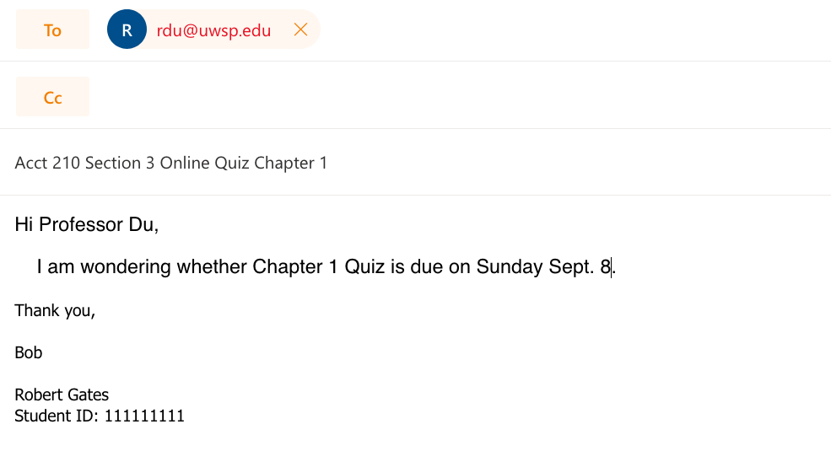
Signature:
√ full name
√ student ID

I check my e-mail on a regular basis and am usually able to respond to your messages within 48 hours during weekdays. However, if the appropriate email format is not followed, response may delay.

I want to know how you are doing as the course progresses, especially if any problems come up. Communication takes effort from both parties! Please feel free to stop by my office or set up an appointment with me to discuss any questions or concerns you may have.

SBE Mission
The UW-Stevens Point School of Business and Economics creates career ready graduates and leaders through applied learning. We serve the businesses, economy, and people of the greater Central Wisconsin region. We specialize in preparing students for success by providing professional development experiences, access to employers, and in-demand skills.

The SBE achieves its mission by valuing:
- Talent development
- Lifelong learning
- Career preparation
- On the job experiences
- Community outreach
- Regional partnerships
- Continuous improvement

Accreditation Commitment:
SBE is accredited by the Association to Advance Collegiate Schools of Business (AACSB), a designation earned by only 5 percent of world business schools. Accreditation instills a culture of continuously improving our programs through connections with local business leaders, alumni and the community.

Program Learning Objectives
Students will be able to apply core concepts, models and methods from business, accounting and economics in identifying and solving problems.

Students will be able to recognize and analyze an ethical dilemma, applying an appropriate ethical framework.

Course Description
Principles, concepts, and procedures of financial accounting essential to the preparation, understanding, and interpretation of accounting information.

Course Structure
This course will be delivered entirely online through the course management system Canvas. You will use your UWSP account to login to the course from the Canvas Login Page. If you have not activated your UWSP account, please visit the Manage Your Account page to do so.
On Canvas, you will access online lessons, course materials, and resources. At designated times throughout the semester, you will take quizzes and exams on Canvas.

Canvas Support
• Click HELP from within Canvas for links to support via email and chat.
• Call Canvas Support for Students at 1 (833) 828-9804.
• Canvas Student Guides
• Canvas Video Guides
- A self-paced Student Training / Orientation course is available for self registration in Canvas.

UWSP Technical Assistance
If you need technical assistance at any time during the course or to report a problem with Canvas you can:
- Visit with a Student Technology Tutor
- Seek assistance from the HELP Desk

Tutoring
Tutoring in Math and Science (TIMS) in the Tutoring-Learning Center (TLC) offers free drop-in tutoring to support you in your introductory accounting classes. In addition, TIMS offers the option for individual accounting tutoring sessions. The tutors are UWSP students who have done well in their classes and who are here to share their successful study habits and content knowledge to help others succeed. Discussing concepts and processes together clarifies and solidifies knowledge, and the tutors are eager to study with you. If you have questions about the schedules or would like to make an appointment, please visit the TLC in ALB 018 (library basement), email (tlctutor@uwsp.edu), or call (715) 346-3568 for information.

Accounting Tutoring

What | Details | Schedule | Cost
Drop-In Tutoring Center | TBD | https://www.uwsp.edu/tlc/Pages/dropInTutoring.aspx | Free
One-on-One Tutoring | By appointment | Visit ALB 018 (library basement) to make a request.  https://www.uwsp.edu/tlc/Pages/CA-tutoring.aspx | $9.00/session*  *Fee waived for students  listed as low-income

Grading

Exam 1 | 100 Points
Exam 2 | 100 Points
Exam 3 | 100 Points
Quizzes  Discussions | 100 Points  25 Points
Total | 425 Points

Extra Credit
There are extra credit opportunities throughout the semester. The instructor will make announcements through email.

Grading Scheme

Letter Grade* | Percentage
A | 93-100%
A- | 90-92.9%
B+ | 87-89.9%
B | 83-86.9%
B- | 80-82.9%
C+ | 77-79.9%
C | 73-76.9%
C- | 70-72.9%
D+ | 67-69.9%
D | 60-66.9%
F | 0-59.9%

*No upgrade in letter grade will be given. The final percentage grade is calculated based on 425 points. A half percent upgrade will be worth one multiple choice in an exam. Therefore, it won’t be fair to other students to round up percentage to upgrade the letter grade for any individual.

Exams
There are three exams, with each accounting for 100 points. All exams are online, open book and in multiple choice format. You will be able to access these exams under the Quizzes tab on Canvas on the scheduled dates. A zero will be automatically given if an exam is not submitted within the time limit
- Please refer to the class schedule for exam dates.
  - There are 40 multiple choice questions in each exam.
  - Exam 1 covers chapter 1, 2, 3, and 4 (80 minutes).
  - Exam 2 covers chapter 5, 6, 8, and 9 (80 minutes).
  - Exam 3 is comprehensive, which covers chapter 1, 2, 3, 4, 5, 6, 8, 9, 10, 11, 13, and 14 (80 minutes). Exam 3 is the final exam.

  - The exams will be open online from 12:00AM-11:59PM on the scheduled exam dates. You must finish the exams by 11:59PM on the exam dates, which means you will need to start the exam at least before 10:40PM to get the full 80 minutes. Once an exam is started, it will be automatically graded as zero by the system when time is out.

  - Only one attempt is allowed for each exam.
  - Past exams will be available for review:
  - Exam 1 and 2 will be available for review starting from Dec. 2, 12:00AM.
Should you not be able to take the exams on the scheduled dates, you must notify me at least two weeks in advance, except emergency situations. No make-up exam will be given unless you demonstrate in advance (and the instructor agrees) that a significant life-event prevents you from taking a quiz or if you have a documented emergency.

Quizzes
Thirteen online quizzes will be given throughout the semester, each accounting for 10 points. The Syllabus Quiz is required. Three lowest-score chapter quizzes will be dropped from your final grade. Therefore, 100 quiz points will be included in your final grade.

- The quizzes will be offered online on Canvas.
- Refer to the Class Schedule at the end of the syllabus for specific due dates.
- Syllabus Quiz is due on Thursday Sept. 5 at 11:59PM.
- Chapter Quizzes are due on Sundays on Canvas at 11:59PM.
- All quizzes are open now. You can study at your own pace.
- Each quiz has 10 multiple-choice questions.
- The overall quiz grade is capped at 100 points.
- You will have 20 minutes to work on these questions.
- A zero will be automatically given if a quiz is not submitted within the time limit.
- You have two attempts on each quiz. The quiz grade will be the average of two attempts.
- The second attempt is not required. If you are satisfied with your first attempt, you could skip the second attempt and use the first attempt alone as your quiz grade.
- The quizzes will be due at 11:59PM on the scheduled dates. These dates are specified in the Class Schedule, as well as displayed in the Canvas Calendar. You must finish the quizzes by 11:59PM on the scheduled dates, which means you will need to start the quizzes at least before 11:40PM to get the full 20 minutes.

- Past quizzes will be available for review once they have reached the due dates.
Should you not be able to take the quizzes on the scheduled dates, you must notify me at least two weeks in advance, except emergency situations. No make-up quiz will be given unless you demonstrate in advance (and the instructor agrees) that a significant life-event prevents you from taking a quiz or if you have a documented emergency.

Assignments
End of Chapter Exercise problems are assigned for each chapter. Solutions to exercise problems are provided on Canvas under HomeTab Solutions to Exercises Module. These End of Chapter Exercises assignments are NOT collected for grading.

Discussion Board
- A discussion board is set up for this course.
- There are 14 discussion forums. One Q&A, one Self-Introduction, and 12 weekly discussion forums.
- Feel free to post to the Q&A forum with any questions you may regarding this course.
- You are required to posted on the Self-Introduction forum. This post is due on Wednesday Sept. 4 at 11:59PM on Canvas Discussion Board. (5 Points)
  - Your self-introduction (3 Points)
  - Respond to at least two other students’ post. (1 point each)
- You are required to post four out of the 12 weekly discussion forums for grades. (5 points each, 20 points total)
  - You are required to take a picture of your solutions to an assigned End of Chapter Exercise problem and upload it with any important notes to this discussion. If your handwriting is not legible, you will not receive credit. (3 points)
  - First add the picture to Files on Canvas, and then insert the image from Files to your posts.
  - Also, provide meaningful feedback to at least two other students. (1 point each)
  - The assigned discussion questions are highlighted in red in the course schedule at the end of the syllabus.
  - These weekly posts are due on Fridays at 11:59PM on Canvas.
  - Solutions to discussion questions are posted on D2L under weekly folders and will be available when each discussion ends.
- Total discussion points are 25.

Pro Events
Pro Events are NOT required for this online course.

Asking Questions
Questions or concerns could be posted on the course discussion forums to seek answers from classmates or could be sent to me via email. I will review the discussion forums regularly. I will usually reply my emails within 48 hours during weekdays. However, if the appropriate email format is not followed, response may delay.

Build Rapport
If you find that you have any trouble keeping up with the course, make sure you let your instructor know as early as possible. As you will find, building rapport and effective relationships are key to becoming an effective professional. Make sure that you are proactive in informing your instructor when difficulties arise during the semester so that we can help you find a solution.

Netiquette Guidelines
Netiquette is a set of rules for behaving properly online. Your instructor and fellow students wish to foster a safe online learning environment. All opinions and experiences, no matter how different or controversial they may be perceived, must be respected in the tolerant spirit of academic discourse. You are encouraged to comment, question, or critique an idea but you are not to attack an individual. Working as a community of learners, we can build a polite and respectful course community.

The following netiquette tips will enhance the learning experience for everyone in the course:
- Do not dominate any discussion.
- Give other students the opportunity to join in the discussion.
- Do not use offensive language. Present ideas appropriately.
- Be cautious in using Internet language. For example, do not capitalize all letters since this suggests shouting.
- Popular emoticons such as ☺ or / can be helpful to convey your tone but do not overdo or overuse them.
- Avoid using vernacular and/or slang language. This could possibly lead to misinterpretation.
- Never make fun of someone’s ability to read or write.
- Share tips with other students.
- Keep an “open-mind” and be willing to express even your minority opinion. Minority opinions have to be respected.
- Think and edit before you push the “Send” button.
- Do not hesitate to ask for feedback.
- Using humor is acceptable

Late Work Policy
Be sure to pay close attention to deadlines—there will be no make-up exams or quizzes, or late work accepted without a serious and compelling reason and instructor approval.

Commit to Integrity
As a student in this course (and at this university) you are expected to maintain high degrees of professionalism, commitment to active learning and participation in this class and also integrity in your behavior in and out of the classroom. The policies and procedures defined by the Chapter UWSP 14 will be followed. For more information see http://www.uwsp.edu/dos/Pages/Academic-Concerns%20for%20Students.aspx.

Students should work on the quizzes and exams individually. Any form of collaboration during the quiz or exam is prohibited. Any discussion regarding the quiz or exam before the scheduled day is over is prohibited.

Americans with Disabilities Act
Students who may need accommodations or services to achieve course objectives should contact the Disability Services Office (346-3365) as soon as possible.

